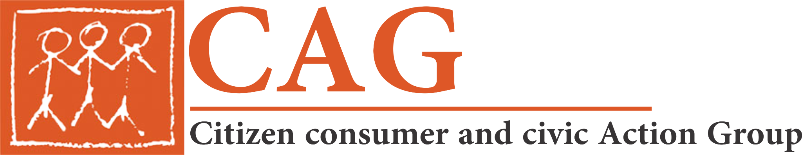

Understanding Chennai’s Master Plan from a Transport Perspective
Press Release

For immediate release
Chennai, March 08 , 2022

What can a good master plan for Chennai city achieve? Experts and citizens gathered to discuss this, from a transport perspective, at a webinar organized by Citizen consumer and civic Action Group on the 7th of March.

Over the years, Chennai has grown into a rambling city, bursting at its seams. In an effort to accommodate this unprecedented growth, master plans have been conceptualised and published. However, even after the creation of several of these statutory documents, their efficacy remains debatable. The Chennai Metropolitan Development Authority (CMDA) published Chennai’s Second Master Plan (SMP) in 2008 aiming to create an inclusive, economically vibrant, and sustainable city by 2026. Chennai now deliberates its third master plan with a focus on the expansion of the Chennai Metropolitan Area (CMA) and gains in infrastructure supply for the city. The third plan is to be launched by 2026. and will be part of the Tamil Nadu Housing and Habitat Development Project (TNHHDP), a World Bank-financed initiative of the state government.

‘A robust master plan can be ambitious but more importantly, must be achievable; it must include citizens’ views, for that is the ultimate aim of the plan - to build a city which offers its residents a sustainable lifestyle and equitable access to its resources’, said Sumana Narayanan, Senior Researcher, CAG. The webinar offered just that - a space to discuss the evolution and transformation of master planning and mobility in Chennai and a platform where citizens could discuss their aspirations for the third master plan.

Prof. A Srivasthan (Head, Center for Research on Architecture and Urbanism, CEPT University) highlighted how Chennai has kept up with a population growth, not through careful planning, but through reactive arrangements. The result is therefore what he described as a ‘badly cooked pizza - with some over-cooked bits and several, still soggy’. He added that “Primarily, plans look at the city as a closed system - but in reality, a city is open-ended and dynamic. Planning should therefore be kept flexible, keeping up with the city’s changing needs’. He suggested that frequent interim reviews will keep the plan in touch with reality.

Ms Aswathy Dilip South Asia Director, ITDP) who focused on the evolution and role of public transport within the fabric of Chennai said that ‘Only 60% of Chennai’s residents have a bus-stop within a 10 minute walk’. This partly explains the growing number of private vehicles on Chennai’s roads, the perpetual deficiency in parking spaces and heightened pollution levels in the city. She also cautioned against constantly building new roads and expanding old roads as ‘more roads just means more private vehicles, and more congestion’

At the end of the webinar, the call from citizens and experts was unanimous - better public transport, safer non-motorised transport and a more joint-up transport system that offered consistent first and last mile connectivity.

For further information, contact: Sumana – 9445395089 | sumana.narayanan@cag.org.in

About CAG
Citizen consumer & civic Action Group (CAG) is a thirty six year old nonprofit and non-political organisation working on citizen rights and good governance. It has worked primarily to protect the interests of consumers and citizens of Chennai even as its efforts have had state level and even national level impacts.

