Data-driven planning for Solid Waste Management in Chennai

Harsha Anantharaman

Working Paper

*Introduction*  
  
Solid Waste Management (SWM) arguably represents = the greatest challenge facing most Indian cities today, including Chennai which produces over 5000 MT of waste daily. However, policy-makers continue to have little to no access to reliable data to inform the planning, design and implementation of SWM systems.[1] This paper seeks to illustrate the retrograde impact(s) that the absence of reliable data has on SWM policy and practice in India. These include poor and iniquitous service provision, the inability to deploy appropriate SWM technologies, failure to develop targeted policy mechanisms for different types of waste producers and inability to assess the efficacy of different policy strategies.

Against this context, stakeholder engagements in Chennai in early 2013-14 prioritized a data-informed pilot intervention emphasising Door-to-Door collection, Segregation-at-Source and decentralized processing of waste as a step forward. The intervention consisted of a A three-step data collection and planning exercise undertaken in Corporation of Chennai Ward - 173 in 2013-14 is described below. This was preceded and followed by a series of stakeholder consultations and sought to inform a ward-wide pilot based on Zero Waste principles.  
 **Step 1: Mapping waste producers:** The mapping exercise entailed the construction of a detailed map of all waste producers and SWM relevant infrastructure in the ward through a simple paper-mapping methodology. Over 15,000 waste producers were mapped, including 14,443 households. This figure exceeded the State’s then-latest available demographic data by a staggering 41.5%, pointing both to the lack of reliable data and the gaps in service provision that arise from this.   
 **Step 2: Waste characterization study**: This step in the intervention involved an intensive survey of 750 households and their waste (a 5% sample) over 9 days to determine prevailing SWM practices as well as quantities and composition of waste. Among other insights, the survey established per household waste generation rates at .864 kg/day. These numbers represent one of the few robust estimates of household waste generation rates not just in Chennai, but in India as a whole. Our data also contest some widely-held assumptions that the quantity of waste produced by households’ increases significantly with socio-economic status. Rather, we observed a weak relationship between household socio-economic status and waste generation rates, with some lower income households bucking the trend altogether, producing more waste than middle and high income households in the same area.   
  
**Step 3: Planning with data**: Deploying the data generated through the mapping and waste characterization study as planning tools, we developed a detailed, community-fed proposal for a ward-wide Zero Waste pilot. The proposal was work-shopped with Ward residents in a series of community meetings before being accepted by the civic body. The data and maps were particularly invaluable in legitimizing pro-poor and pro-environmental ideas, long held by researchers and activists in the policy space. Salient among these was an affirmation that households compliance with regards to source-segregation could be boosted through concerted outreach and education efforts.

The mapping and waste characterization studies conducted in Ward 173 present a variety of interesting and useful datasets with relevance for public policy and planning. These included spatial representations of the study area, comprehensive demographic data on various categories of waste producers as well as intensive data on levels of waste generation in the ward and the physical composition of said waste.



The sample survey, the first of its kind in Chennai, helped establish or question the validity of certain existing notions regarding waste generation and composition in this context. Notably, the results affirmed that waste producers in India produce a greater preponderance of organic waste with over 70% of the ward’s waste being accounted for by organic matter. We also found that households higher on the socio-economic scale produced more waste, with a greater proportion of their waste being recyclable as compared to lower income households. However, this difference was not as pronounced (in fact it was very subtle) as suggested by a number of past studies.



The mapping exercise also helped reveal some of the key failures of the current SWM system. Data on the placement of dumpsters and their state of disrepair and incidences of overflowing garbage paint a compelling picture of a ward with certain chronically under-served areas. These areas were invariably in dense, low-income settlements. Thus a data collection exercise helped make concrete and provide evidence for the long-held views of activists that low-income settlements receive little or no services from the municipality.   
  
The outcome of the data collection and planning exercise has been a phased introduction of Zero Waste to Ward 173. Only one locality within the Ward has had its SWM system reformed, while lack of availability of land, financial restrictions and other sues typical of the Indian urban context have undermined efforts to scale up to the entire ward. However, a sustained community engagement has been maintained via community meetings with a view to generating comprehension and support for the proposals from residents of the area.  
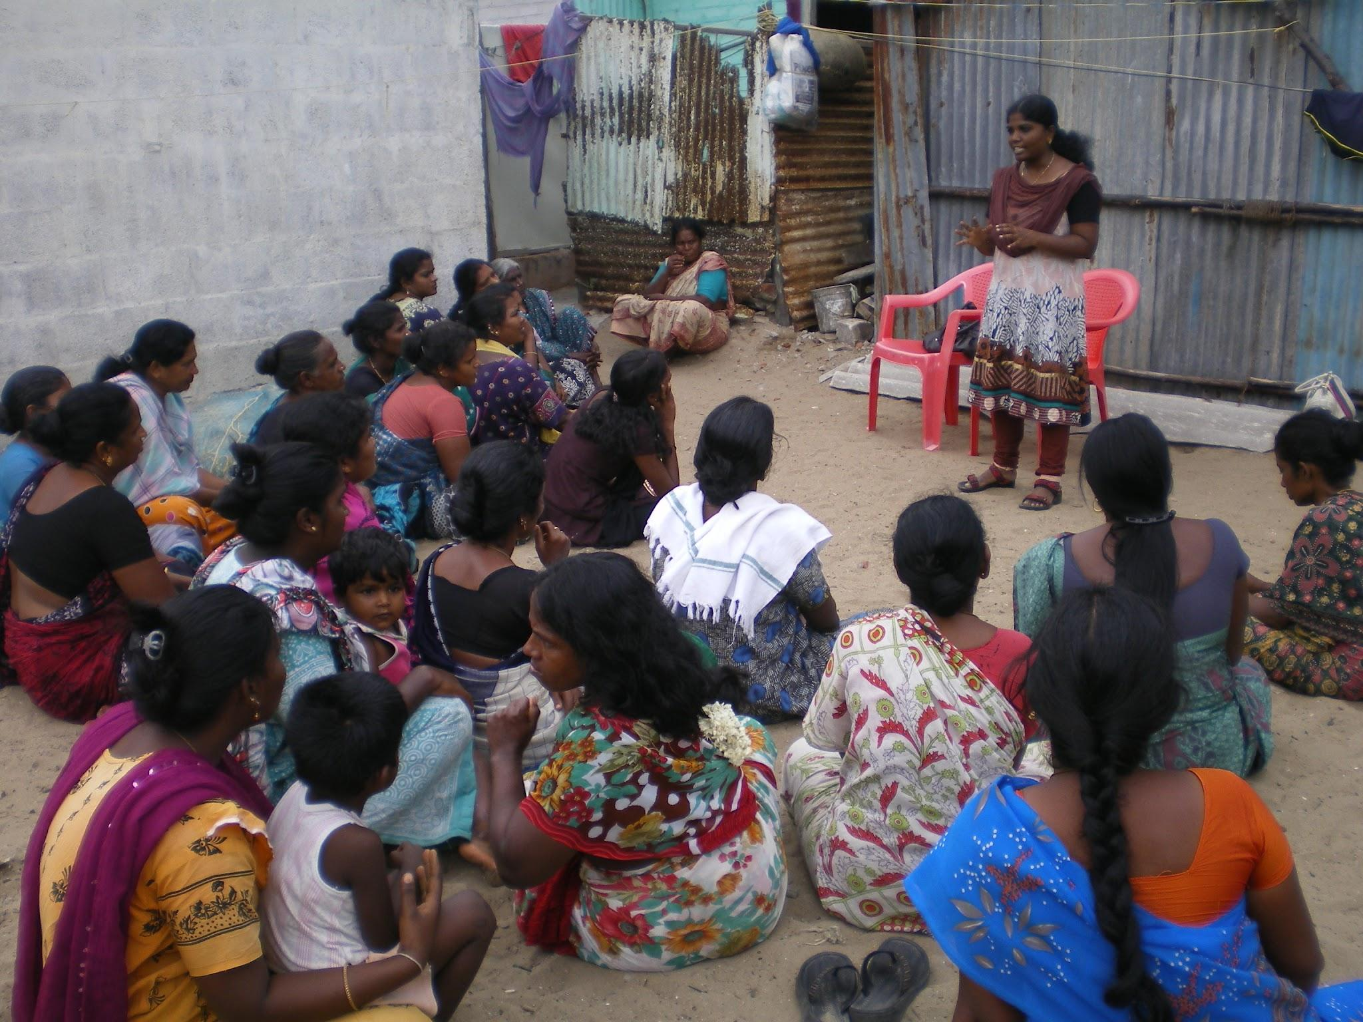

The studies described above also suffered from a few shortcomings, the most noteworthy of which was the fact that many household respondents either had had little to no sanitary waste for us to weigh or chose not to hand it over for reasons of propriety. Future studies should seek to address this concern proactively at the time of recruitment. Additionally, being a one-time engagement, the survey does not account for seasonal variations in waste generation. Similarly, while the survey’s time series included a weekend, the lack of data relevant to a day/time of festivities is a shortcoming.

However, notwithstanding the above caveats, the data and learnings from the Ward 173 studies are robust and comprehensive enough to plan effectively for the ward as well as to develop our understanding of urban solid waste systems. The data collection methodologies have been made available in the form of a toolkit which can be applied in other Indian and Asian cities to inform SWM planning, design and implementation.

1. The Central Pollution Control Board, the country’s primary environmental oversight authority has said in its “Action Plan for Management of Municipal Waste” (2015) that, “Presently, no systematic and authentic data on MSW generation at National Level and subsequently at State, District and at city / town level is available.”